Krishi Setu
A Location-Aware Digital Marketplace for Direct Farmer–Buyer Interaction and Intelligent Crop Decision Support
Renuka Raut¹, Sudeep Kuralkar², Himanshu Sherje³
¹ Assistant Professor, Department of Computer Science and Business System
²,³ Student, Department of Computer Science and Business System
St. Vincent Pallotti College of Engineering and Technology, Nagpur, India

Abstract
Agricultural inefficiencies in developing economies are largely driven by fragmented market access, price opacity, and dependence on intermediaries. Farmers often lack visibility into real-time demand and are compelled to cultivate traditional crops with uncertain profitability. This paper presents Krishi Setu, a mobile-based, location-aware digital marketplace designed to bridge the communication gap between farmers and buyers (off-takers). The system enables direct crop listing, real-time interaction, and intelligent price estimation, thereby facilitating transparent and efficient agricultural trade.
The proposed platform integrates geolocation services, real-time communication, and predictive insights to support informed crop selection and pricing decisions. A multi-role architecture accommodates farmers, buyers, and administrators, ensuring scalable and role-specific functionality. By leveraging modern mobile technologies and cloud-backed services, the system minimizes latency and enhances accessibility even in low-resource environments.
The key contribution of this work lies in combining marketplace functionality with decision-support mechanisms, enabling farmers not only to sell produce but also to strategically plan cultivation based on demand signals. The platform aims to reduce intermediary dependency, improve price realization, and create a data-driven agricultural ecosystem.

Keywords
Agricultural Marketplace, Farmer-Buyer Interaction, Location-Based Services, Crop Prediction, Price Optimization, Mobile Application, Digital Agriculture

1. Introduction
Agriculture remains a critical sector in many developing nations, yet it continues to operate under systemic inefficiencies. One of the most persistent challenges is the disconnect between producers and end buyers, leading to the dominance of intermediaries who often dictate prices. Farmers frequently lack access to real-time market data, resulting in uninformed crop selection and reduced profitability.
In addition to pricing issues, the absence of a structured communication channel prevents farmers from identifying demand trends. Consequently, many continue to cultivate traditional crops regardless of market needs, further exacerbating income instability. Buyers, on the other hand, face difficulties in locating reliable suppliers that meet their quality and quantity requirements.
The proliferation of smartphones presents an opportunity to address these challenges through digital solutions. However, existing agricultural applications often focus on advisory services rather than enabling direct trade.
This paper introduces Krishi Setu, a mobile application that establishes a direct, transparent, and location-aware marketplace. By integrating communication, geolocation, and predictive features, the system empowers farmers to make economically viable decisions while enabling buyers to efficiently source agricultural products.

2. Literature Survey
Several digital agriculture platforms have been developed to address issues in farming ecosystems. Applications such as AgriApp and Kisan Suvidha primarily focus on providing weather forecasts, crop advisory, and government scheme information. While these tools enhance awareness, they do not facilitate direct trade between farmers and buyers.
Marketplace platforms like DeHaat and Ninjacart attempt to streamline supply chains but often operate as intermediaries themselves rather than enabling peer-to-peer interaction. This limits price transparency and farmer autonomy.
Research systems incorporating crop prediction models have shown promise in improving yield planning; however, they are typically isolated from real-time market demand, reducing their practical applicability.
A critical gap exists in integrating marketplace functionality, real-time communication, and decision support into a unified system. Krishi Setu addresses this gap by enabling direct interaction while simultaneously assisting farmers in selecting crops based on demand and price signals.

3. Problem Statement
Farmers lack access to a unified digital platform that enables direct interaction with buyers, real-time market visibility, and data-driven crop decision support. This results in dependency on intermediaries, suboptimal crop selection, and reduced income potential.

4. Proposed System
Krishi Setu is designed as a multi-role mobile application that connects farmers and buyers within a location-aware digital ecosystem. The system allows farmers to list crops, receive inquiries, and negotiate directly with buyers, eliminating the need for intermediaries.
The platform incorporates an intelligent pricing mechanism that estimates standard market prices based on available data, enabling farmers to avoid underpricing. Additionally, a crop suggestion module provides insights into high-demand crops, encouraging a shift from traditional to market-driven cultivation.
The workflow begins with user authentication, followed by role-based dashboard access. Farmers can upload crop details, including quantity, price expectations, and location. Buyers can search listings using filters such as crop type, price range, and proximity. A real-time chat module facilitates negotiation, while geolocation services assist in logistics planning.

5. System Architecture
The system follows a client–cloud architecture, where the mobile application serves as the client interface and cloud services handle data storage, synchronization, and processing.
The frontend is developed as a mobile application optimized for low-resource devices, ensuring accessibility for rural users. Backend services are designed to support real-time data exchange and scalable user management.
Core architectural components include:
- Authentication Module for secure user access
- Marketplace Module for crop listing and discovery
- Communication Module enabling real-time chat
- Location Services Module for mapping and proximity filtering
- Data Processing Layer for price estimation and crop suggestions
Cloud-based databases ensure data consistency and availability, while APIs enable integration with external services such as maps and weather systems.

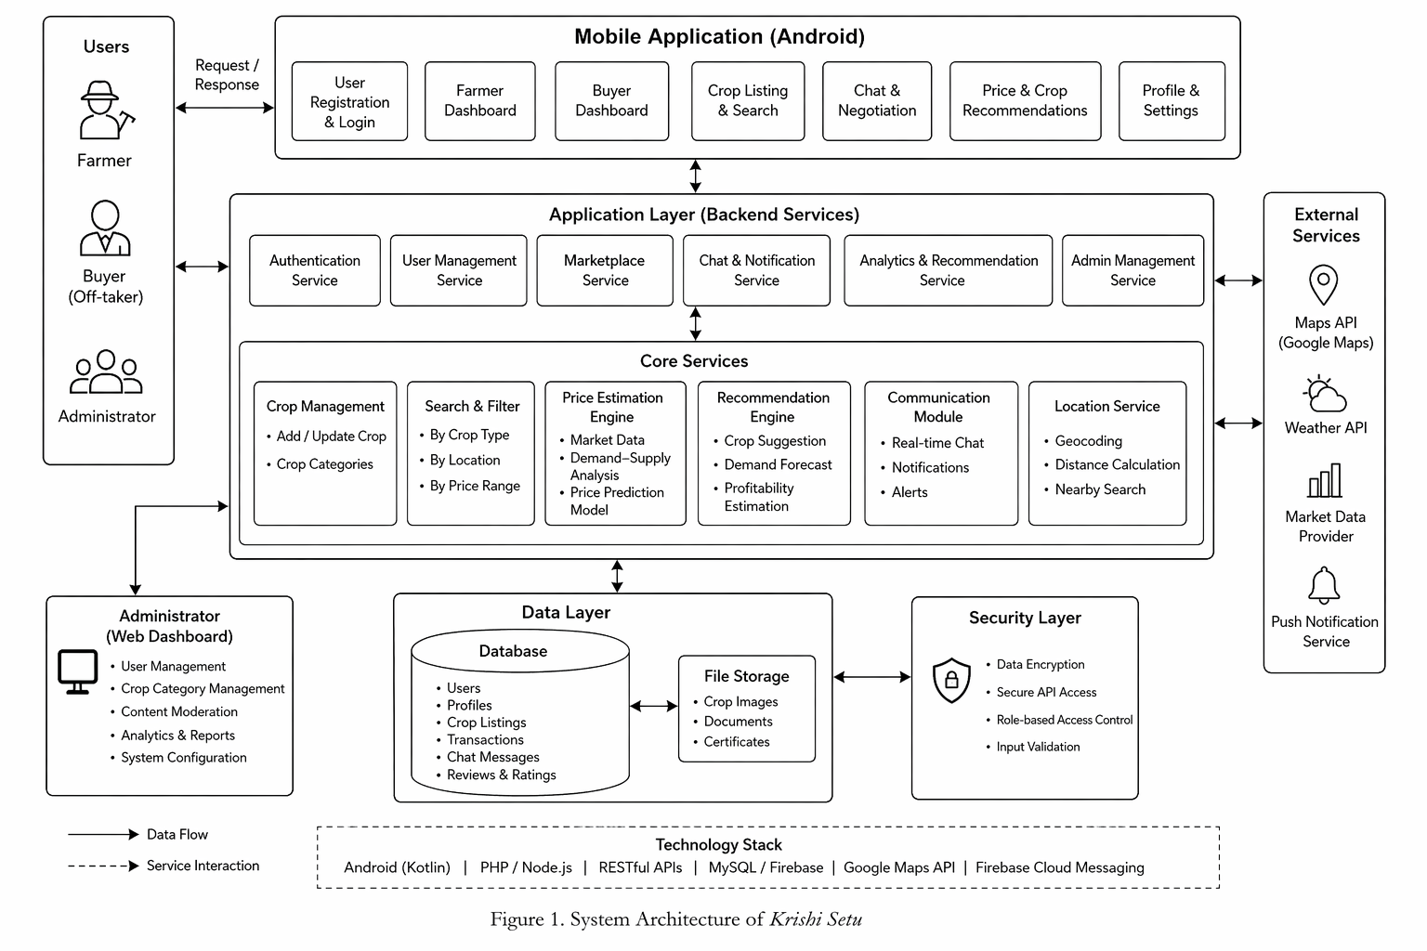
React Native | Node Js | Express Js | Java Kotlin | Python | MongoDB | Supabase | Firebase | Cloudinary | Maps (open source. )
6. Methodology
The system operates through a structured workflow beginning with user registration and role assignment. Once authenticated, users interact with role-specific dashboards.
Farmers input crop details, which are stored in the database and made accessible to buyers. Buyers query the system using search filters, retrieving relevant listings based on location and preferences. When a match is found, the communication module enables direct negotiation.
Simultaneously, the system processes historical and contextual data to generate price suggestions. Crop recommendation logic evaluates demand trends to guide farmers toward profitable cultivation decisions.
Data flow is managed through asynchronous communication between client and server, ensuring minimal latency and real-time updates.
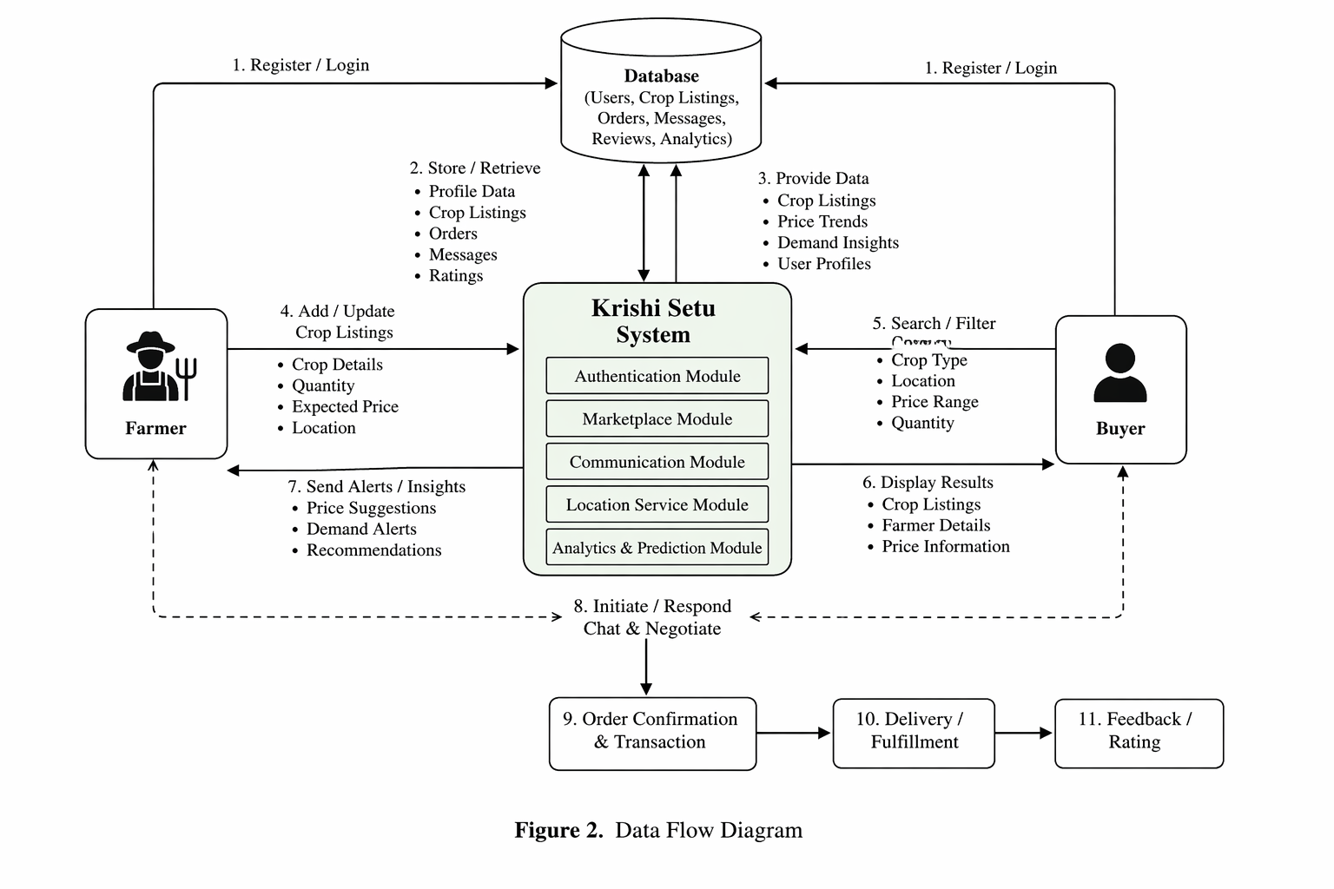

7. Technologies Used
The system leverages a modern technology stack to ensure scalability and performance. The mobile application is developed using a cross-platform or native framework, enabling efficient deployment across devices.
Backend services utilize a server-side framework capable of handling concurrent requests and real-time communication. A NoSQL database is employed for flexible data storage, accommodating dynamic agricultural datasets.
Geolocation functionality is integrated through mapping APIs, allowing accurate distance-based filtering. Real-time communication is supported through socket-based protocols, ensuring seamless interaction between users.
Each technology is selected based on its ability to support scalability, low latency, and ease of integration in resource-constrained environments.

8. Results and Discussion
The proposed system demonstrates significant potential in improving agricultural market efficiency. By enabling direct farmer–buyer interaction, the platform reduces dependency on intermediaries and enhances price transparency.
The integration of predictive features allows farmers to make informed decisions, potentially increasing profitability. Location-based filtering improves buyer efficiency by reducing search time and logistical complexity.
Preliminary observations suggest that such a system can foster a more balanced supply-demand ecosystem, benefiting both producers and consumers.

9. Advantages
The platform offers a decentralized marketplace that empowers farmers with direct market access. Its scalable architecture supports a growing user base without compromising performance. Real-time communication enhances transaction efficiency, while predictive insights improve decision-making.
The system’s mobile-first design ensures accessibility in rural regions, making it a practical solution for real-world deployment.

10. Limitations
Despite its advantages, the system faces certain limitations. Dependence on internet connectivity may restrict usability in remote areas. The accuracy of price prediction and crop recommendation modules depends on the quality and volume of available data.
User adoption may also be influenced by digital literacy levels among farmers, requiring additional training and awareness initiatives.

11. Future Scope
Future enhancements include the integration of machine learning models for advanced predictive analytics, enabling more accurate crop and price forecasting. The incorporation of IoT devices and wearable sensors can facilitate real-time monitoring of soil and crop conditions.
An offline-first architecture can improve accessibility in low-connectivity regions. Blockchain integration may also be explored to ensure transaction transparency and traceability.

12. Conclusion
Krishi Setu presents a comprehensive solution to longstanding challenges in agricultural markets by combining direct trade, location-based services, and intelligent decision support within a single platform. By reducing intermediary dependency and enhancing market visibility, the system has the potential to significantly improve farmer income and operational efficiency.
The proposed architecture and methodology demonstrate scalability and adaptability, making the platform suitable for widespread adoption. With further enhancements, Krishi Setu can contribute to the evolution of a data-driven and equitable agricultural ecosystem.

14. References
[1] R. Kumar and S. Singh, “Digital Transformation in Agriculture: Opportunities and Challenges,” International Journal of Agricultural Science, vol. 12, no. 3, pp. 145–152, 2021.
[2] P. Sharma et al., “Mobile-Based Agricultural Advisory Systems: A Review,” IEEE Access, vol. 9, pp. 56789–56802, 2022.
[3] M. Patel and A. Desai, “Smart Farming Using IoT and Data Analytics,” Elsevier Procedia Computer Science, vol. 165, pp. 204–211, 2020.
[4] S. Verma, “Market Linkage Models for Farmers in Developing Economies,” Springer Agricultural Systems, vol. 8, pp. 89–101, 2019.
[5] K. Reddy and V. Rao, “Location-Based Services in Mobile Applications,” IEEE Communications Surveys & Tutorials, vol. 23, no. 2, pp. 1021–1045, 2021.

